Review for sprint one
The sprint about calculator
The calculator is important in the software so that we can calculate the customer's requests quickly and we provide the time for system and the customer. we need to do design and implement it
The calculator is Done.
- And there are no amendments
- 1-designed
- 2-coded
- 3-code review
- 4-design review
- 5-tested
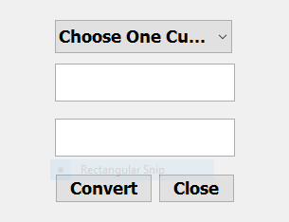
- 6- user acceptance tested
- For the following currency you will be responsible for :
Currency conversion (convert)
It should be done as follows

Review for sprint two
The sprint about convert
Currency conversion to facilitate the customer and to deal with all currencies around the world to achieve the highest profit
The Converter is Done
- And there are no amendments
- 1-designed
- 2-coded
- 3-code review
- 4-design review
- 5-tested
- 6- user acceptance tested
- For the following currency you will be responsible for:
The List of Orders (menu)
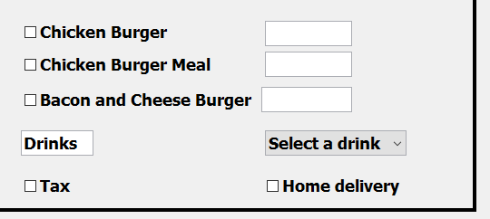
It should be done as follows
Review for sprint three
The sprint about menu
List of Orders Here we record all that is available to us to record customer requests as desired
The Menu is Done.
- And there are no amendments
- 1-designed
- 2-coded
- 3-code review
- 4-design review
- 5-tested
- 6- user acceptance tested
- For the following currency you will be responsible for receipt & reset & exit
It should be done as follows

Review for sprint four
The sprint about receipt & reset & exit
We have to register the customer's requests, so I have to check with the customer or we have to register another customer's requests.
Receipt & Reset & Exit is Done

- And there are no amendments
- 1-designed
- 2-coded
- 3-code review
- 4-design review
- 5-tested
- 6- user acceptance tested



